GREENWOOD PUBLIC SCHOOL, ADITYAPURAM
OUR MOTTO - DEVELOPMENT WITH DELIGHT
SYLLABUS FOR THE MONTH OF JULY (2019-20)
CLASS-NURSERY
SUBJECTS |  | ACTIVITY+USE OF ICT | PARENTS INVOLVEMENT
English | Oral : Twinkle –Twinkle , A for Apple.  Written :Standing lines, sleeping lines , slanting lines , Zig-Zag lines , Curved lines , Alphabets A,B,C,D.  Workbook: Page No. 2-9  Theme : Myself  Sentence structure : I am a Boy /Girl.  Vocabulary Building: School , Teacher , Classroom, Bus , Chairs , Table.  Recognition Alphabets: A,B,C,D | 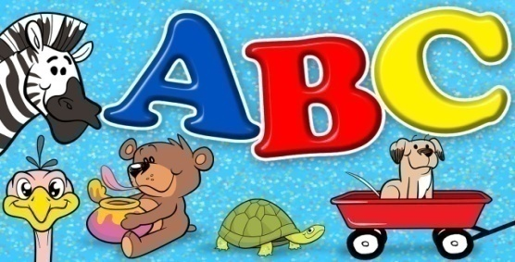 | Help your child in learning rhymes and written work
Hindi | Oral : dfork,¡ & vPNh f'k{kk ] canj ekek A  OkkD; jpuk % eSa ,d yM+dk / yM+dh gWw A  Loj % अक्षर अ- ई  Written : vkM+h ] frjNh js[kk,W ] xksykdkj ,oa v)Zxksykdkj lajpuk,WA  Recognition Alphabets: अक्षर अ- ई  Workbook: Page no 2-9  Sentence structure: यह मेरी कक्षा है! | 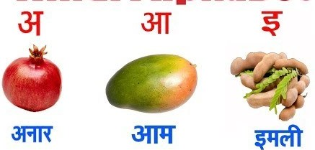 | dfork,sa ;kn djok,Wa rFkk o.kksaZ dh igpku fp=ksa +}kjk djok,W!
Maths | Oral : Counting 1-10  Concepts :Big × Small , Fat × Thin , Long ×Short  Written: Curves and lines , numbers-1,2,3,4  Workbook: Page no 2-9 | 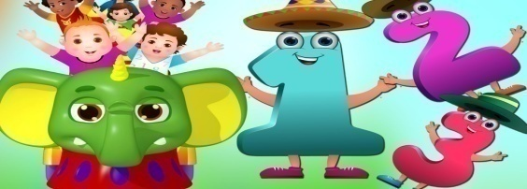 | Motivate your child in counting objects and learning tables.
Drawing | Page no 2-4
G.K. | Oral : Tasty fruits :Apple , Mango , Orange , Grapes , Banana  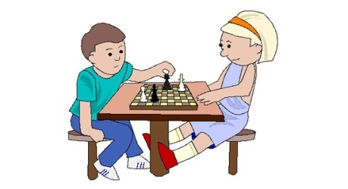  Colours: Green , Yellow , Black , Red , Blue | PPT on Flowers & Fruits  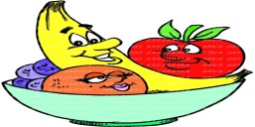 | Help your child to recog. the colours and Fruits.
Music / Dance | Western Dance  Song: Boogie Woogie | Boogie Woogie Song
V.E. | I love my school | PPT on School | Talk to your child about the school
Physical Education | Fun games: Running , Jumping , hopping ……….  Boogie Woogie  Put your right hand in,  put your right hand out  Put your right hand in  And shake it all about.  Do the boogie woogie  And turn yourself around  That's what it's all about.  Do the boogie, boogie  That's what it's all about. |  | Take your child to a park and play some games.
Conversation | English Conversation  1. How are you?  Ans-I am fine thank you  2. What is your name?  Ans-My name is ………..  3. How old are you?  Ans-I am 3 years old.  4. In which class do you study?  Ans-I study in nursery class. | Hindi Conversation  प्रश्न 1- आप कैसे है ?  उत्तर - मैं अच्छा / अच्छी हूँ !  प्रश्न 2- आपकk uke D;k gS ?  उत्तर - मेरा नाम …………. हैं !  प्रश्न 3- आप कितने वर्ष के हैं ?  उत्तर - मैं तीन वर्ष का / की हूँ !  प्रश्न 4- आप किस कक्षा मेँ पढ़ते हैं ?  उत्तर - मैं नर्सरी मेँ पढ़ता / पढ़ती हूँ ! | Help your child in learning Conversation Que/Ans
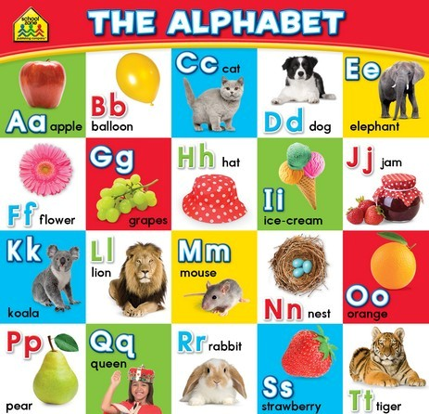
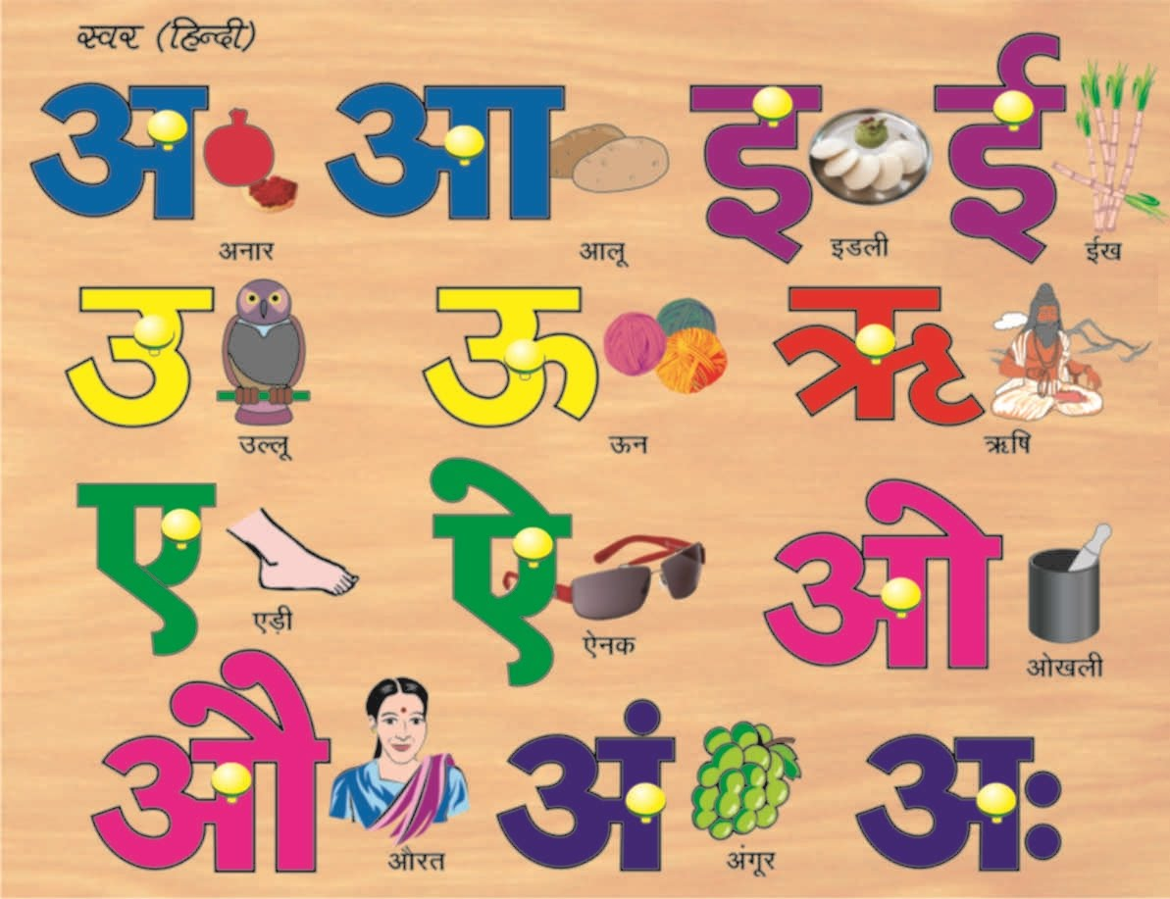

GREENWOOD PUBLIC SCHOOL, ADITYAPURAM
OUR MOTTO - DEVELOPMENT WITH DELIGHT
SYLLABUS FOR THE MONTH OF JULY (2019-20)
CLASS-L.K.G.
SUBJECTS |  | ACTIVITY+USE OF ICT | PARENTS INVOLVEMENT
English | Oral :Rhymes-chubby cheeks, little jack horner  Reading : consonants and vowels chart ,alphabet sounds ‘A’ ‘B’ and ‘C’  Written : Small Cursive letters (a - d) , write the first letter of the picture, dictation, match the following  Vocabulary Building: I, My , We , He , She , You , Me , Boy , Girl. | PPT on letters a-i (small cursive)  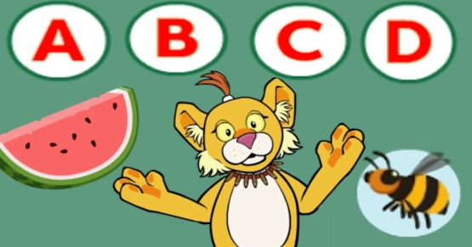 | Help your child in learning rhymes and written work
Hindi | Oral : dfork,¡ & esjh xqfM+;k ] xqM~Mw ] larjs dk isM+  Reading – व्यंजन वर्ण क से तक स्वर अ से अ: तक का पुनः अभ्यास !  Written : व्यंजन वर्ण क से तक ] जोड़ी बनायें , चित्र पहचानकर अक्षर लिखें ,Jqrys[k ! | 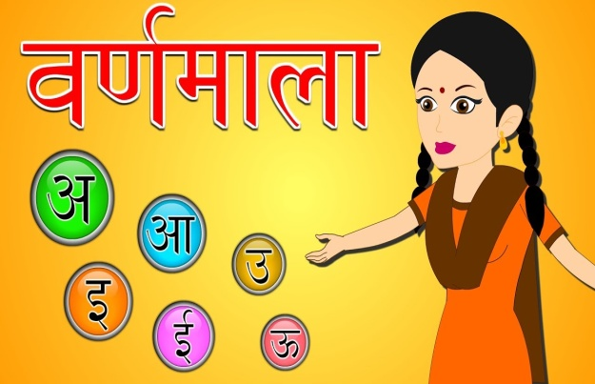 | dfork,sa ;kn djok,Wa rFkk o.kksaZ dh igpku fp=ksa +}kjk djok,W!
Maths | Oral : Number names 1-10 , Table of 2 , Counting 1-80  Written : Counting from 1-80 , Dictation , Reverse counting from 10-1 , fill in the blanks, match the following.  Unit-1 Pre-Number concepts (Page no5-9) | Extra Marks  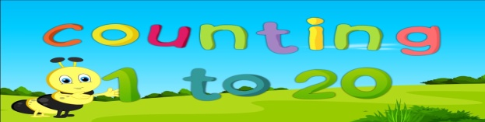  Videos on Number Names | Help your child in learning tables.
G.K. | Oral : Revision of April month syllabus , Pet Animals , Wild Animals | PPT on Parts of the body & Fruits | Make your child learn Myself.
Music | Song: Boogie Woogie , Yellow colour song
Computer | Parts of computer, handling of mouse
V.E. | We should respect our elders |  | Teach Good manners to your child
Drawing | Colour the cylinder and camel (page no 4,5) / Free hand drawing
Physical Education | Indoor games- running, jumping , catching , throwing , picking , passing.
Art & Craft | Umbrella and cloud
Language development | Action Words :– Writing , eating , singing , jumping , drinking , bathing , running , skipping , talking.
Conversation | English Conversation  Q.1 What is your name?  Ans-My name is…………….  Q.2 What is your father’s name?  Ans-My father’s name is…………….  Q.3 What is your Mother’s name?  Ans-My Mother’s name is…………….  Q.4 In which class do you study?  Ans-I study in L.K.G. class. | Hindi Conversation  Yellow Colour Song  Yellow Yellow  Like the Sun  The Colour Yellow is so much Fun!  A baby chick, a sour lemon,  A rubber duckie and juicy melon.  Yellow Yellow,  Like a School Bus,  Come join in and sing with us!  Sing with us…  Yellow Yellow  Like the Sun  The Color Yellow is so much Fun!  Corn on the Crop sweet and yummy  Banana milk shake in my tummy!  1- vkidk D;k uke gS\  m0 esjk uke ---------------- gSA  2- vkids ikik dk D;k uke gS\  m0 esjs ikik dk uke ----------------------- gSA  3- vkidh eEeh dk D;k uke gS\  m0 esjh eEeh dk uke -------------------- gSA  4- vki fdl d{kk esa i<+rs gSa\  m0 eSa d{kk L.K.G. esa i<+rk gw¡@ i<+rh gw¡A | Help your child in learning conversation Que/Ans
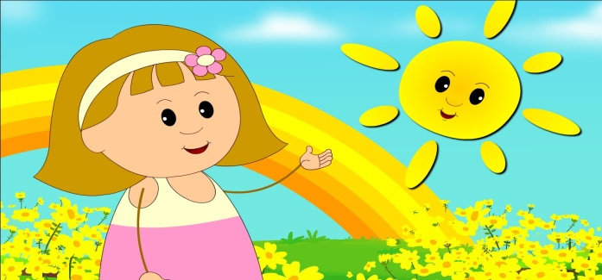
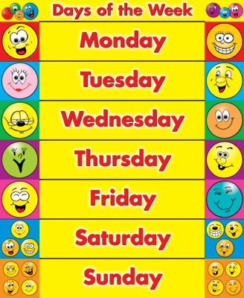

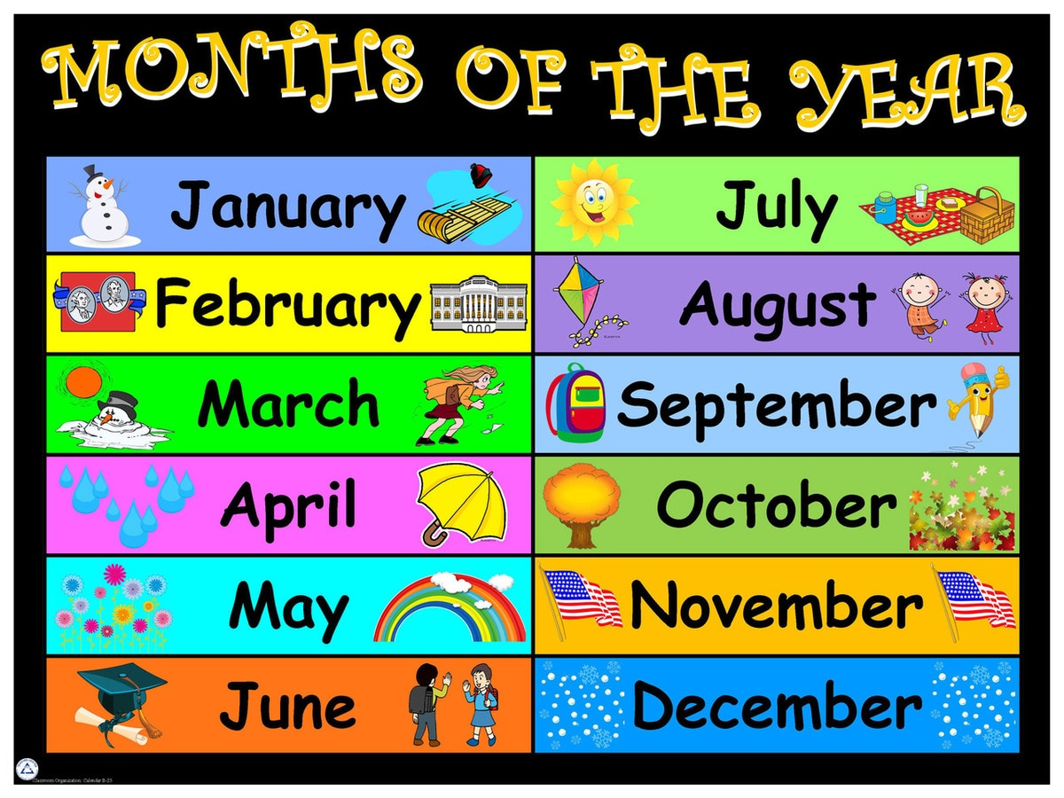

GREENWOOD PUBLIC SCHOOL, ADITYAPURAM
OUR MOTTO - DEVELOPMENT WITH DELIGHT
SYLLABUS FOR THE MONTH OF JULY 2019-20
CLASS-U.K.G.
SUBJECTS |  | ACTIVITY+USE OF ICT | PARENTS INVOLVEMENT
English | Oral:-Rhymes- Ding dong bell, Hey Diddle Diddle opposites  Reading –Page no.- ,8,9,10,11  Written : Revision of small and capital cursive letters, sound of vowel (a,e,i,u,o) , chapter- 5 to 10 vowel ‘a’ with ‘e’ words with ‘ar’ sound, words with ‘ai’ sound , words with ‘ea’ sound , words with ‘ee’ sound words with ‘o’ sound  Vocabulary Building:- School , class room , table , duster , chalk , Board , Teacher.  Workbook page no.- 6 to 13 | 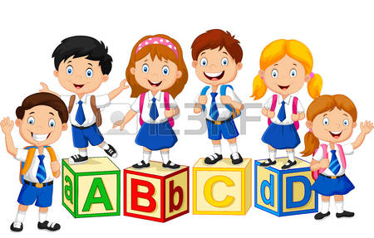 | Help your child in learning rhymes and written work
Hindi | Oral : dfork,W & Mkfd;k ] nks pwgs ] fxurh A  Reading – Page No - 5 to 15  Written : बिना मात्रा वाले चार अक्षर के शब्द , पाठ -3 से पाठ -5 तक vk ( k ) ] b ( f ) ] bZ ( h ) dh ek=k iz'uksRrj ] खाली स्थान , Jqrys[k ] lqys[k ] esjk ifjp; ,oa vk dh ek=k ls bZ dh ek=k rd ckjg[kMhA  Loj ys[ku &ist dzekad & 2 ls 9 rdA | Extra marks  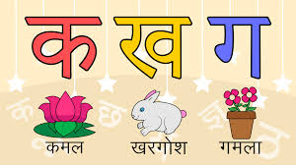  dfork,sa! | dfork,sa ;kn djok,Wa rFkk o.kksaZ dh igpku fp=ksa +}kjk djok,W!
Maths | Oral : Number names (11-30), Table of 3,4 Counting 1-100  Written : Number names (11-30), Table of 2,3 and 4 Backward counting (20-1) after /before/between numbers , numerals , missing numbers.  Workbook :Page no 2-7 | 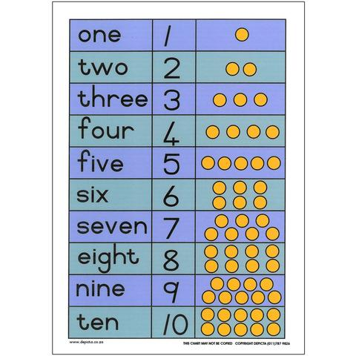  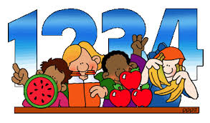 | Motivate your child to count objects and learn tables.
EVS | Oral: Family members , Good habits  Written : Myself , chapter- 1 and 2 Names of family members, our festivals, Types of houses , parts of houses. | PPT on given topics. | Help your child to recog. the colours, fruits & flowers.
G.K. | Name of vegetables, domestic animals , wild animals | 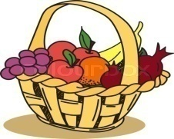 | Help your child read the calendar.
Art / Craft | Page Number : 5, 6 ,7 , 8
Music / Dance | Music:- सरस्वती वंदना Classical Dance  Song: Boogie Woogie
V.E. | Always speak the truth | Yellow Colour Song  Yellow Yellow  Like the Sun  The Color Yellow is so much Fun!  A baby chick, a sour lemon,  A rubber duckie and juicy melon.  Yellow Yellow,  Like a School Bus,  Come join in and sing with us!  Sing with us…  Yellow Yellow  Like the Sun  The Color Yellow is so much Fun!  Corn on the Crop sweet and yummy  Banana milk shake in my tummy! | Motivate your child to help others
Drawing | Page no. – 5,6,7 and 8 | 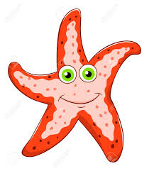
Sports | Frog race, zig-zag , running
Language Development | Welcome to our class, Have a nice day, Nice to meet you.
Conversation | English Conversation ( Myself )  1. What is your name?  2. What is your father’s name?  3. What is your mother’s name?  4. How old are you?  5. Where do you live?  6. In which class do you study?  7. What is the name of your school?  8. What is your favourite food / fruit?  9. What is your favourite colour? | Hindi Conversation  - vkidk uke D;k gS \  - vkids ikik dk uke D;k gS \  - vkidh eEeh dk uke D;k gS \  - vki fdrus o’kZ ds gS \  - vki dgkW jgrs gS \  - vki fdl Dykl es i<+rs gS \  - vki ds fo|ky; dk uke D;k gS \  - vkidh tUe frFkh D;k gS \
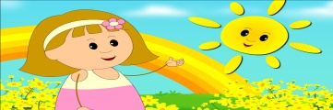
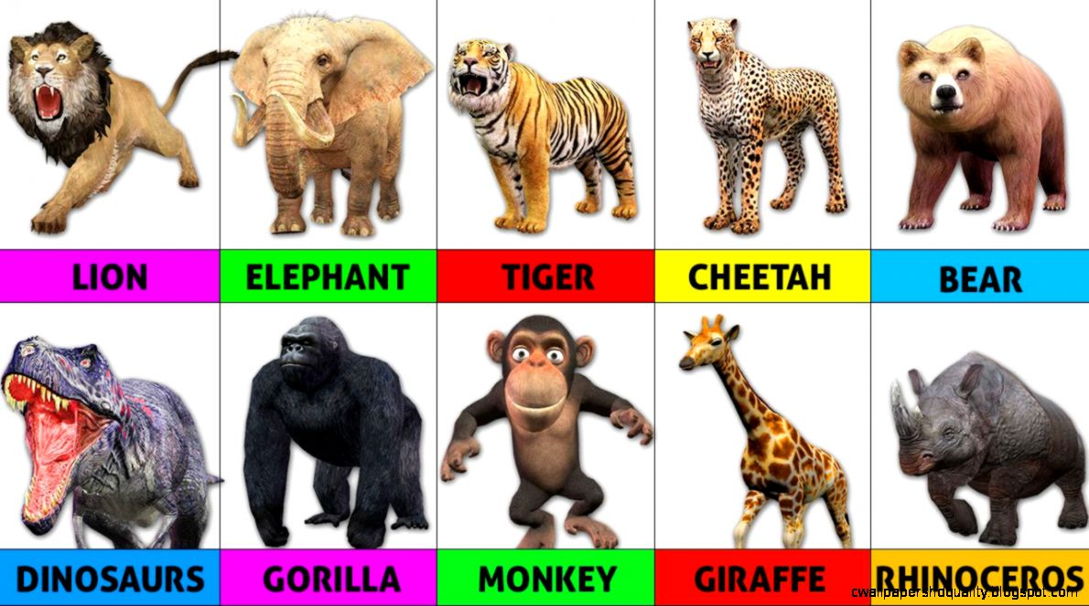
Wild Animals
English Song-Rain
Rain on the green grass
Rain on the tree
Rain on the house top
But not on me.
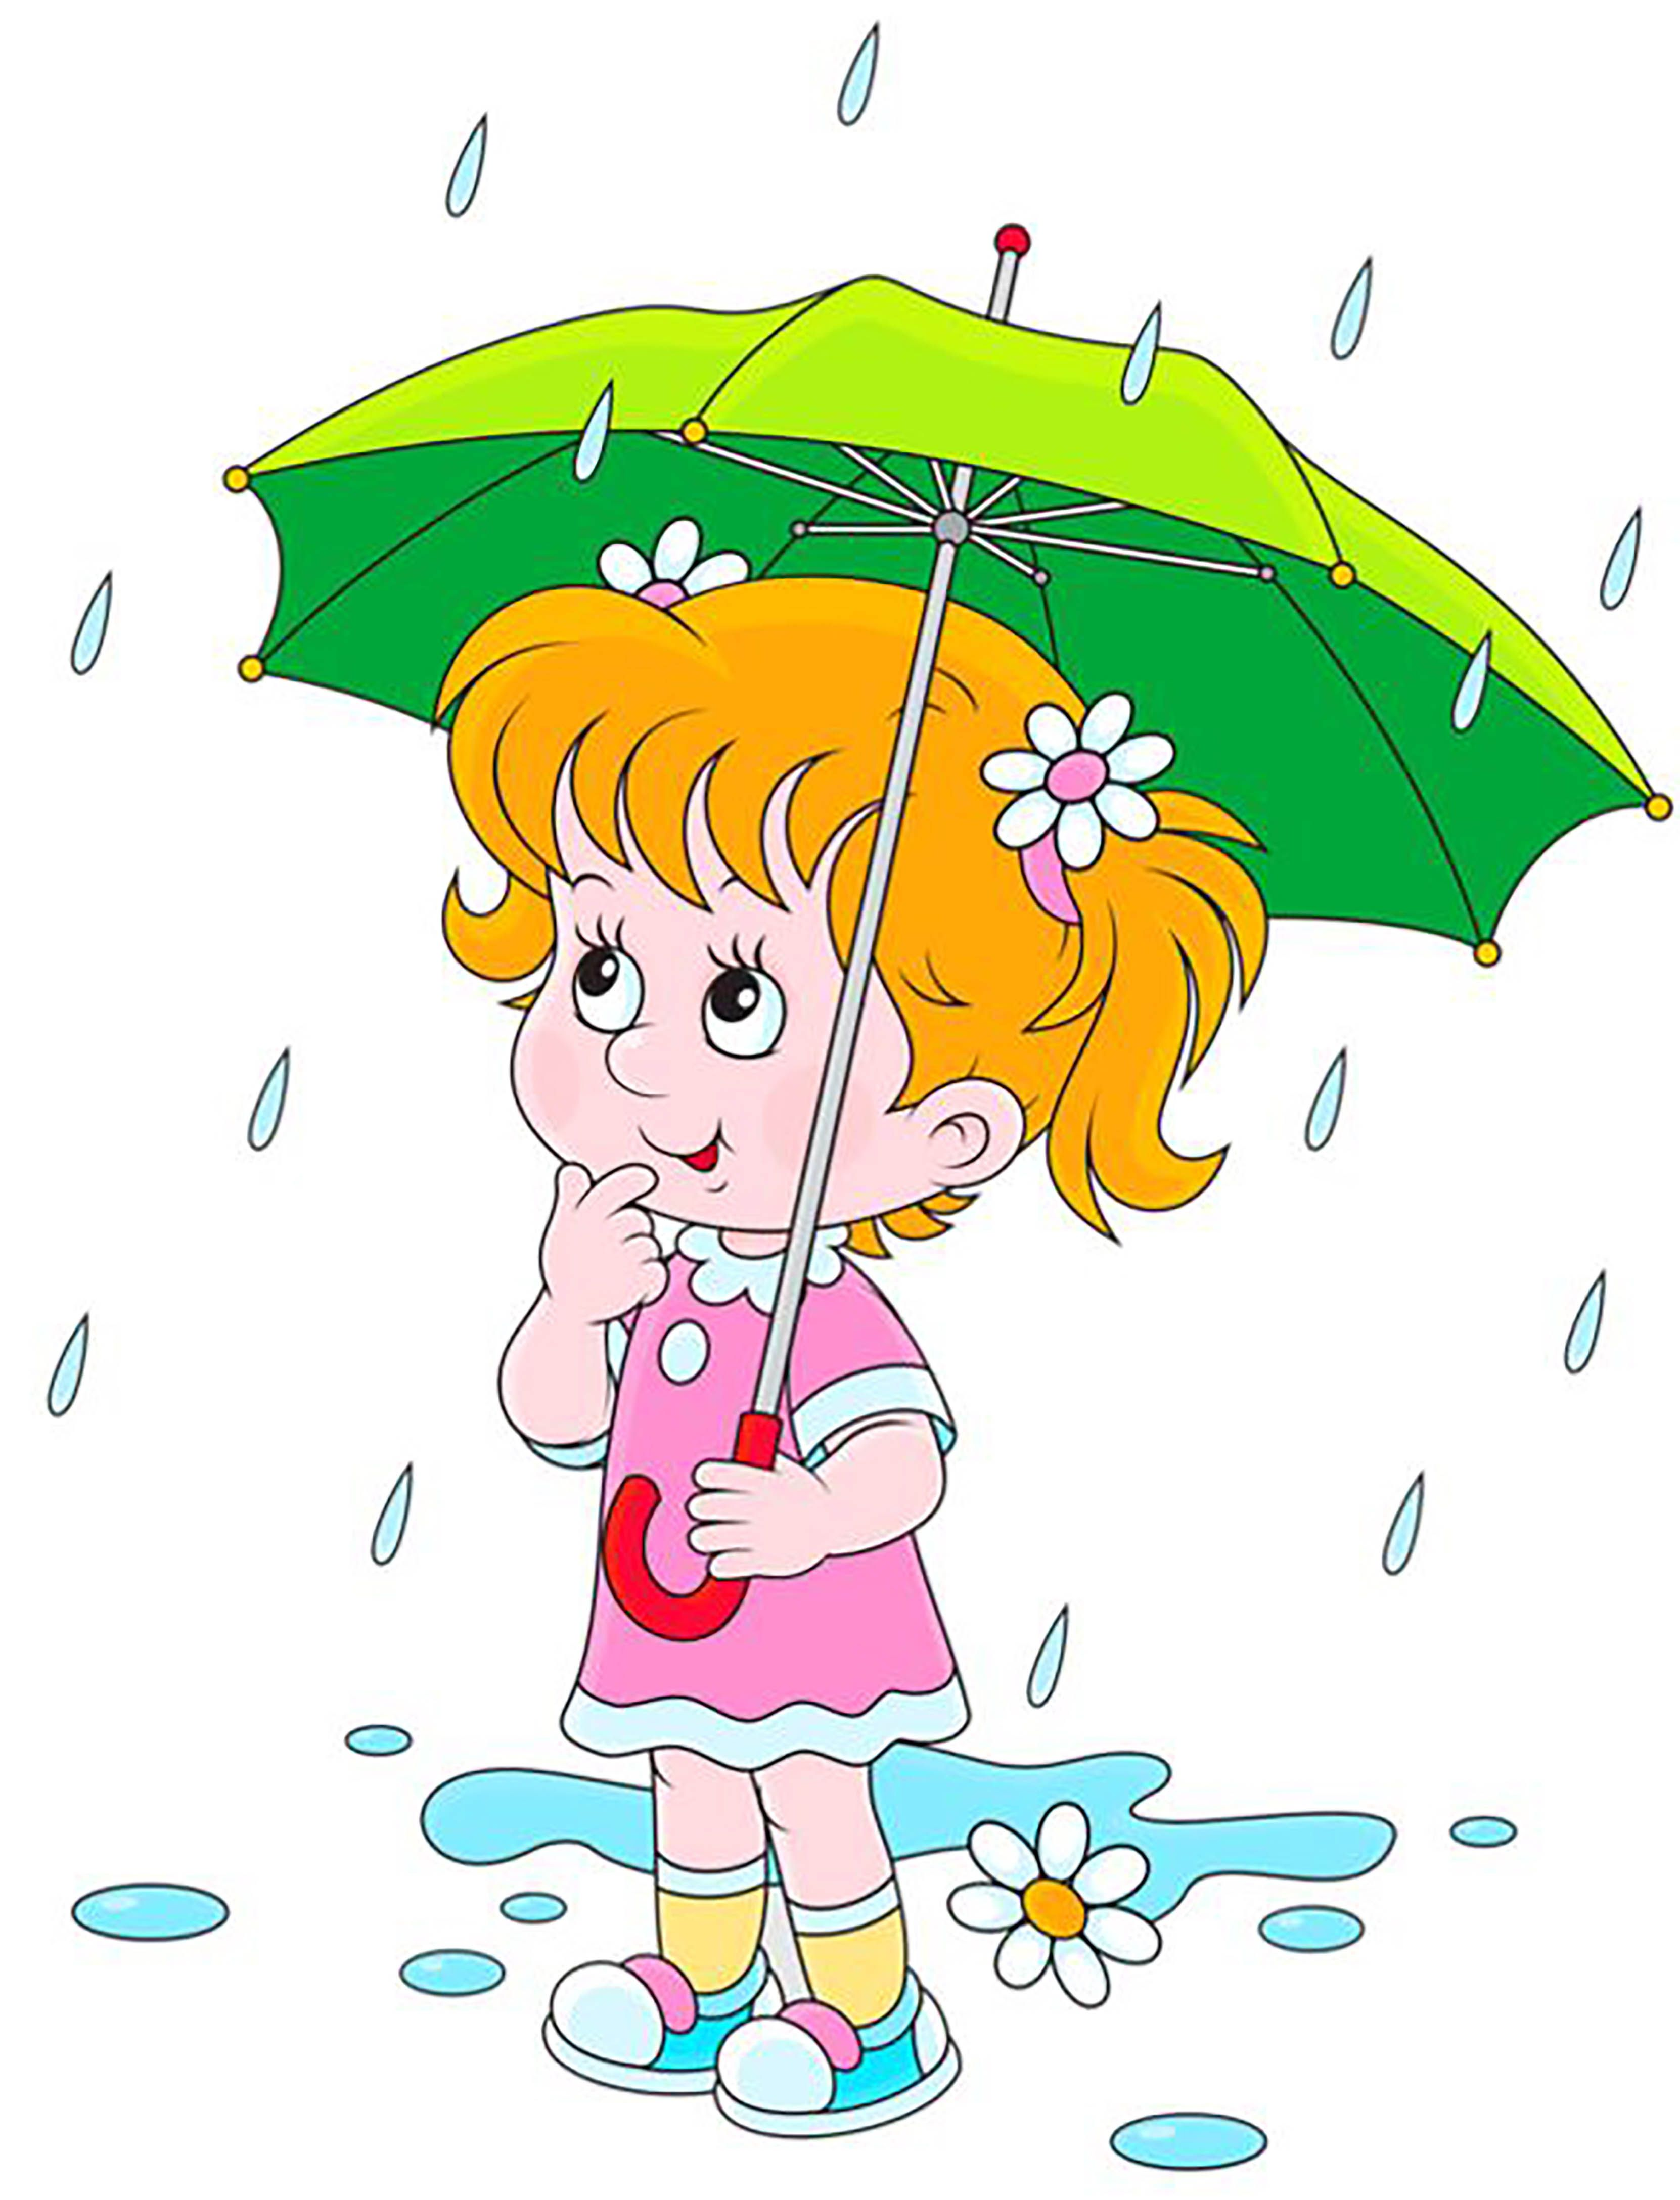
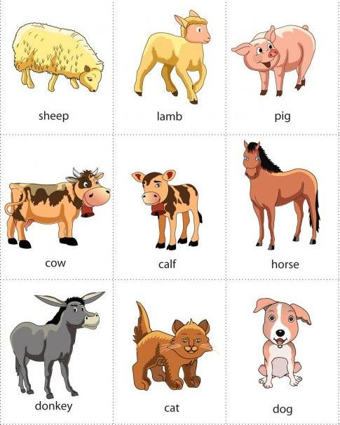
Pet Animals

